Collateral Web

TFS 92351 – Enhance scenarios for object ownership;

TFS 92357 – Multiple Collateral Scenarios

Feature Overview

Modify the process by which scenarios are created and modified to include various scopes. This is to help draw awareness to existing scenarios that already include a certain scope and hopefully minimize, if not completely eliminate, the need for data cleanups.

# Document Change History

|  |  |  |  |  |
| --- | --- | --- | --- | --- |
| Version | Date Changed | Description | Approved By | Date Approved |
| 1 | 08/26/16 | Document started | Rebeca McFarland | 08/26/16 |
| 2 | 09/08/16 | Updated mock-ups and other edits | Bevin Morrissey | 09/08/16 |
| 3 | 09/22/16 | Design regroup | Bevin Morrissey | 09/23/16 |
|  |  |  |  |  |

FPI Credit Products

September 23, 2016

Table of Contents

Collateral Web 1

Document Change History 1

Statement of the Problem 2

FPI RECOMMENDATION 3

View Current Production 4

Create New Scenario 5

Continue with Existing Scenario 7

Edit Scenario Scopes 9

Association Parameter 10

Collateral Analysis Screen 10

Submitting Scenarios to EmPOWER 11

TFS 92351 – Enhance scenarios for object ownership; TFS 92357 – Multiple Collateral Scenarios

## Statement of the Problem

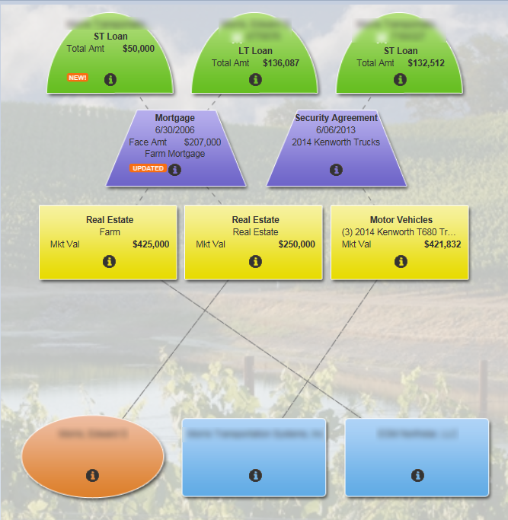

**Employee #1** wants to work on the **short and long term loans** on the left side of the picture (scope #1) in Scenario #1.

**Employee #2** wants to work on the **short term loan** on the right side of the picture (scope #2) in Scenario #2.

If one of these two employees updates collateral belonging to a loan in the opposite scope, the two scenarios become entangled and FPI has to manually clean up data in the database with a script.

We would like to make it more obvious which collateral objects belong to which scope, and make it more difficult to lock up scenarios by creating multiple scenarios that include the same scope.

## FPI RECOMMENDATION

If you **launch** Collateral Web via a **favorites shortcut** or by **entering in the URL** in your browser address bar, once you open a customer, you will see that customer’s “Current Production” Collateral View in **READ ONLY**. See the View Current Production section to continue.

When launching Collateral Web **from EmPOWER**, you will be presented with a “Select” message box of options:

1. View Current Production
2. Create New Scenario
3. Continue with Existing Scenario (*only available if at least one scenario already exists*)

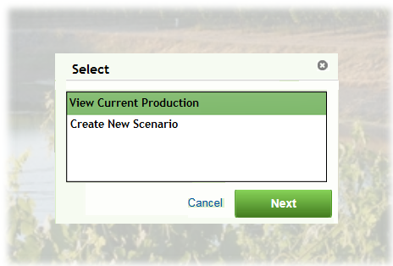

Selecting **“Cancel”** will bring you to your Collateral Web **Home Page** under the customer launched from EmPOWER.

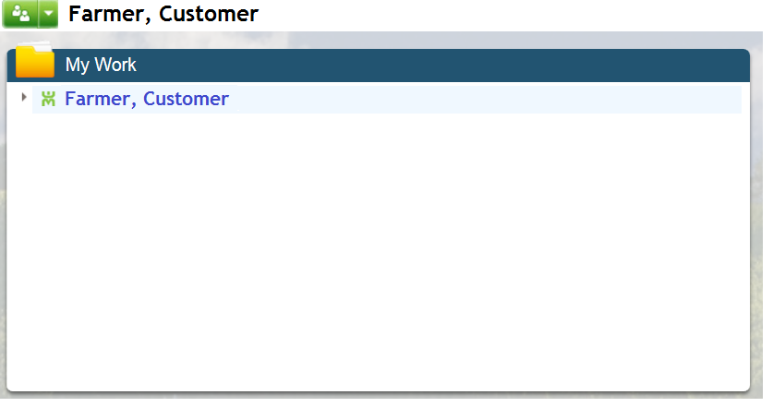

### View Current Production

Selecting **“View Current Production”** opens all Current Production scopes in **READ ONLY**.

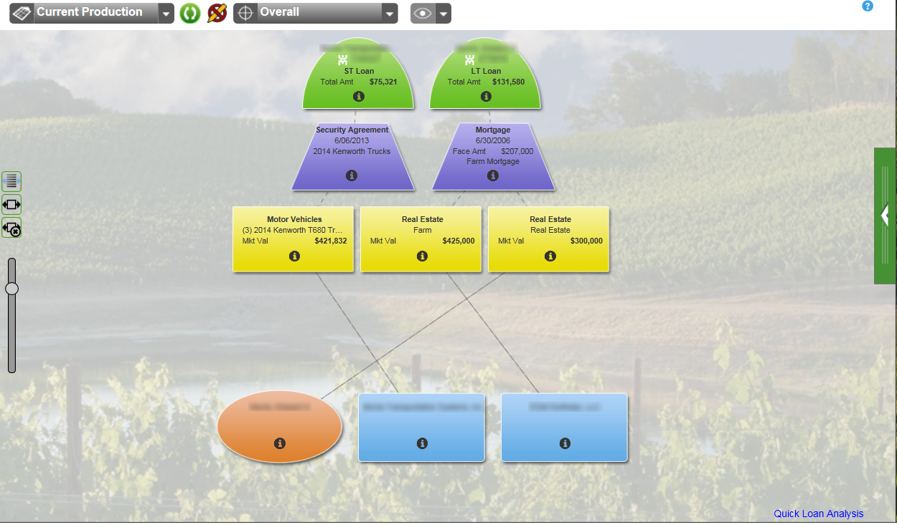

If from here you wish to start a new scenario, select the “Current Production” scenario menu. The existing “Copy Scenario” link will be updated to “**Create Scenario**”.

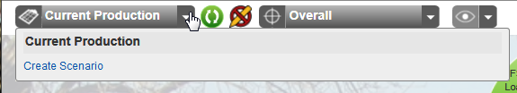

If you then click “Create Scenario”, the Create New Scenario message box will come up. See the Create New Scenario section below to continue.

### Create New Scenario

If you choose to **Create New Scenario**, you will be prompted to enter a label for the new scenario and **select the scope(s)** you would like to include.

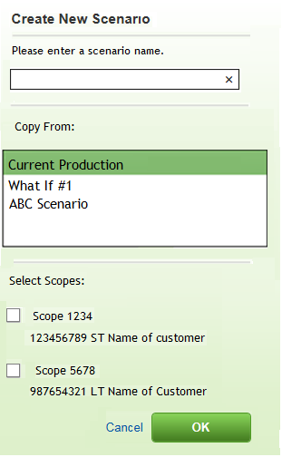

* The scenario from which you are accessing the Create New Scenario feature will be automatically selected in the “Copy From:” field.
* If, however, you came in to Collateral from EmPOWER and had no existing scenarios, “Current Production” will be automatically selected.
* If you click “Cancel”, you will be redirected to this customer’s “Current Production” Collateral View screen in READ ONLY.
* If multiple scenarios exist, you may change the “Copy From:” selection to any of the existing scenarios ***or*** “Current Production”.
* If you are starting from “**Current Production**”, **no scopes** will be selected. You will need to make a scope selection based on the loans, and those loans’ associated collateral objects, that you wish to work on.
* If you are **copying** from another **existing scenario**, the scopes that were included in that existing scenario will be **checked**. You will have the option of adding in any other scopes that were not included in the scenario you are copying from at this point.

Click “OK” to create the scenario.

As soon as you click “OK”, if you have **selected a scope that exists in another scenario**, you will receive an **alert**.

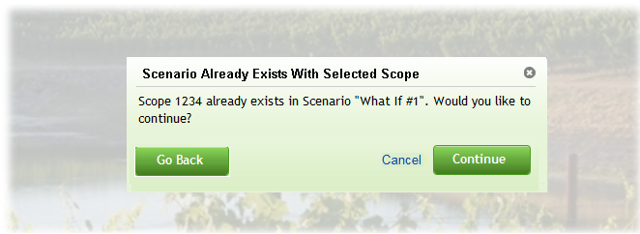

You can choose if you would like to **Cancel** your create process entirely, **Continue**, or **Go Back** to the Create New Scenario window to change your scope selection.

FPI can investigate adding an association parameter that would allow an ACA to set a **cap** on how many scenarios **PER SCOPE** can be created.

This means that if you set the cap to **ONE**, and you attempt to create a new scenario that includes a scope that **is already included** in a different existing scenario, you will **not be allowed** to do so. Click this box to jump to the Association Parameter section below for more information.

Any scopes that were not selected will be grayed out when your new scenario is created.

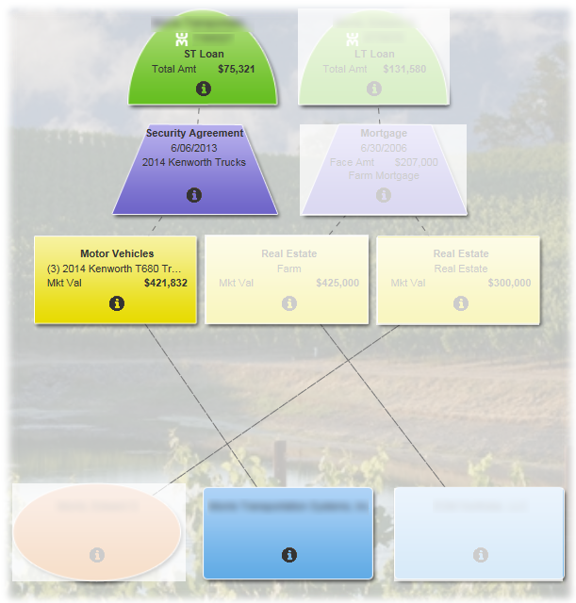

### Continue with Existing Scenario

If, when you first access Collateral Web from EmPOWER, there are **existing** scenarios, you may select “**Continue With Existing Scenario**” and then click “Next”. *(“Cancel” will take you to the Collateral Web Home Page.*)

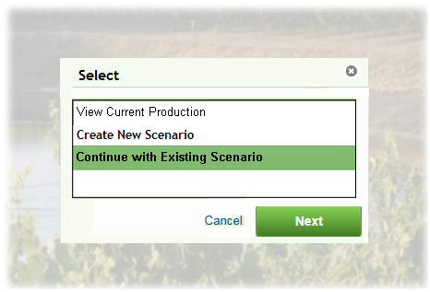

A new window, “Select Existing Scenario”, will provide a list of all existing scenarios and the scopes/loans they include.

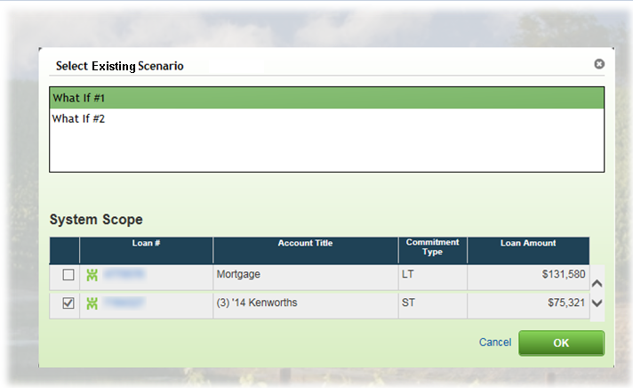

If you click “Cancel”, you will be redirected to this customer’s “Current Production” Collateral View screen in READ ONLY. Or, **select a scenario** and click “**OK**” to open it.

If you choose a scenario that does **not** include the scope with the commitment from which you accessed Collateral Web, the following alert will pop up:

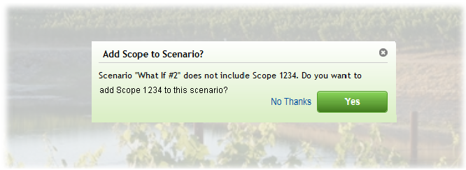

“**No Thanks**” will open the scenario **without** adding Scope 1234.

Selecting **“YES”**, IF Scope 1234 is not already part of another existing scenario, **adds** Scope 1234 to “What If #2” and opens “What If #2” on the Collateral View screen.

If, however, Scope 1234 is already part of another existing scenario, a second alert will pop up.



You can choose if you would like to:

* **Cancel** your process entirely and go to “Current Production” Collateral View for this customer
* **Continue**, and Scope 1234 will be added to scenario “What If #2” which will be opened on the Collateral View screen
* **Go Back** to the **Select Existing Scenario** window to change your scenario selection.

FPI can investigate adding an association parameter that would allow an ACA to set a **cap** on how many scenarios **PER SCOPE** can be created.

This means that if you set the cap to **ONE**, and you attempt to create a new scenario that includes a scope that **is already included** in a different existing scenario, you will **not be allowed** to do so. Click this box to jump to the Association Parameter section below for more information.

### Edit Scenario Scopes

As you work on your scenario, if you decide that you need to **add** any of the scopes **not initially included** (*those that are currently grayed out*), you will need to go back to the **scenario menu**, and click the “**Edit Scenario Scopes**” link.

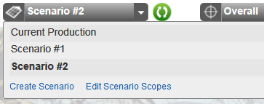

This “Edit Scenario Scopes” link will only appear in this menu when you have scenarios available to edit.

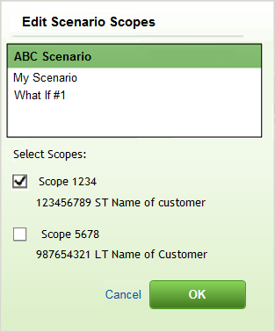

As soon as you click “OK”, if you have selected a scope that exists in another scenario, you will receive an alert. You can choose if you would like to **Continue**, or **Go Back** to the Edit Scenario Scopes window to change your scope selection.

FPI can investigate adding an association parameter that would allow an ACA to set a **cap** on how many scenarios **PER SCOPE** can be created.

This means that if you set the cap to **ONE**, and you attempt to create a new scenario that includes a scope that **is already included** in a different existing scenario, you will **not be allowed** to do so. Click this box to jump to the Association Parameter section below for more information.

Once you have added a scope to your scenario, it will no longer be grayed out on the Collateral View screen.

### Association Parameter

**If desired**, FPI can **investigate** adding an association parameter that would allow an ACA to place a cap on the number of scenarios allowed PER SCOPE.

This would **allow the number of scenarios per scope to be configurable by association**.

If only one is allowed, and you try to create a new scenario that includes a scope that is already part of an existing scenario, you will **not** be allowed to continue.

If a different maximum is set, say three, once three scenarios exist that include that particular scope, you will not be allowed to create a fourth that includes that scope.

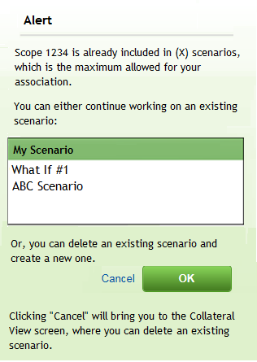

You will be able to either:

* Continue your work on that scope by opening one of the existing scenarios that includes that scope already.
* Delete one of the existing scenarios so that you can create a new one that includes that particular scope.

### Collateral Analysis Screen

The Collateral Analysis screen will also be updated to mimic the Collateral View screen in regards to editing scopes, based on the scenario and which scopes are currently included in the scenario.

### Submitting Scenarios to EmPOWER

By submitting a scenario to EmPower, all other scenarios that include the same scopes as those included in the scenario being submitted will be **DELETED**.

This is consistent with how the application works today.